

Excellence In Learning

Weaverham High School EAL Strategy

The Weaverham Way: EAL
Intent:
At Weaverham High School our vision is clear. We aim to be a vibrant, thriving and successful school where every member of our community feels valued, safe and supported to ensure they surpass their potential. We want every child to enjoy their own journey of discovery, acquire a thirst for knowledge, creativity and imagination and develop a love for their learning. We want pupils to leave our school not just with qualifications showing their academic success, but also with the capacity to think clearly and deeply, a desire to act with integrity and to show kindness and empathy to others, and with the character and leadership experience they need to thrive in the world. For our pupils who are learning English as an additional language, this includes recognising and valuing their home language and background. We hold an unwavering belief that every child who walks through our doors, regardless of prior experience, academic ability or personal barriers has the ability to meet and exceed their potential. Our mission is to enable students to become the best version of themselves.

The DFE definition of an EAL learner is:
A pupil is recorded to have English as an additional language if they are exposed to a language at home that is known or believed to be other than English. This measure is not a measure of English language proficiency or a good proxy for recent immigration.’
(DfE Schools, Pupils and their Characteristics July 2020)

Weaverham High School is committed to meeting the needs of all students who are learning English
as an additional language. This strategy will enable us to provide a consistent approach in working with EAL learners.

As a school, we will work together to:
- Promote equality of opportunity for all EAL learners in line with the Equality Act 2010
- Ensure access to the curriculum through quality first teaching and relevant scaffolds
- Help students to speak, understand, read and write English
- Support the continued use of the students’ home languages
- Assess and monitor pupils progress and learning to inform further teaching
- Work to remove barriers that stand in the way of our EAL learners fulfilling their potential
- Make sure EAL learners are not inappropriately labelled or grouped as SEND or low ability
- Acknowledge individual strengths and celebrate cultural identities
- Provide an environment which celebrates diversity and supports English language learning
- Provide EAL learners with a safe and welcoming environment where they are valued and encouraged to participate

Context

Weaverham High School is an average sized, oversubscribed school with 1168 students on roll. On indicators of deprivation, WHS is in the 4th percentile with FSM/PP lower than national average. Our FSM6 population is 19.25.% v 26.92% National Average. There are lower than average numbers of SEND students under category K at 8.98% v 11.92% National Average. The percentage of SEND pupils under category E is 1.03% V 2.15% National Average. The number of students whose first language is not English is 1.00% V 17.48% National Average. This is a small, but increasing cohort. The languages spoken by our EAL cohort include; Romanian, Cantonese, Bengali, Polish, Ukrainian, German, Russian, Turkish and French.

Weaverham High School currently has 8 EAL students on roll. Of which:

0 are new to English
1 is in the early stages of language acquisition
2 are developing confidence
1 is competent

4 are fluent

Language | Number of Students | 7 | 8 | 9 | 10 | 11
Cantonese | 1 |  |  |  | 1
Ukrainian | 4 |  |  |  | 3 | 1
Russian | 1 |  |  |  |  | 1
Bemba | 2 |  | 1 |  | 1

Implementation

Admission

During the admission meeting the following steps will take place:
- Pupil questionnaire completed detailing previous education and background information. ​
- Parents/ Carers supported with completing the admissions form. ​
- Start date agreed which allows the family and school, time to prepare. ​
- Arrangements for baseline testing made. ​
- Pupil buddy assigned and briefed. ​
- Timetable established. ​
- Teachers informed of start date and all relevant staff provided with information about the pupil. ​
- Arrangements made for pupil’s first day. ​
- The form tutor prepares pupils in the tutor group for welcoming the new arrival. ​
- Bi Lingual Dictionary purchased. ​
- Flash Academy log in generated. ​
- *New Arrivals in KS4 – Pupil timetable established, including suitable option choices and intervention classes. The decision regarding GCSE entry will be made by the SLT.

Key information from the admissions meeting is included in the pupil passport to support teaching and learning in the classroom.

Assessment

Prior to the pupils start date baseline assessments will take place in reading and English proficiency. The pupil’s proficiency band will be identified in order to inform the development of the pupil passport to inform classroom strategies for teaching and learning. The pupil will also be assigned to the relevant intervention groups. Proficiency assessment will then take place termly.

Proficiency bands are as follows:

A – New to English
B – Early Acquisition
C – Developing Competence
D – Competent
E – Fluent

Roles and Responsibilities

A collegiate approach to EAL pupils is the most impactful. As such collective responsibility is held by all staff to identify and remove barriers that stand in the way of our EAL students’ achievement and inclusion.

The EAL Teacher will:
- Oversee the day-to-day organisation of the EAL provision.
- Carry out pre-admission, base line and periodic assessments of pupil proficiency, tracking and monitoring progress.
- Work with AHT Intervention to generate and update pupil passports.
- Deliver bespoke intervention session to improve the proficiency of English as an additional language.
- Track and monitor pupil progress.

The Literacy Leader will:
- Ensure the pupils are placed on the relevant literacy intervention.
- Track and monitor progress with regard to reading.
- Carry out termly assessment to inform the suitability of the provision and impact.

In addition, the AHT: Intervention will:

- Work collaboratively with the Intervention EAL intervention teacher to develop and implement an excellent EAL provision.
- Timetable the suite of EAL intervention and communicate this with pupils, parents/carers and staff.
- Maintain the EAL register and communicate updates with staff.
- Produce pupil passports for EAL students to support Teaching and Learning in the classroom.
- Keep abreast of educational guidance and EAL issues.
- Track and monitor pupil progress at each assessment point.
- Maximise opportunities for staff CPD.

Teaching and Support staff will:
- Implement the use of the support strategies outlined in the pupil passport to enable pupils to assess the curriculum and develop their proficiency.
- Set appropriate home learning activities.
- Share good practice.
- Track and monitor the progress of pupils.

The following flow chart details the actions that are taken based on the pupils identified proficiency.

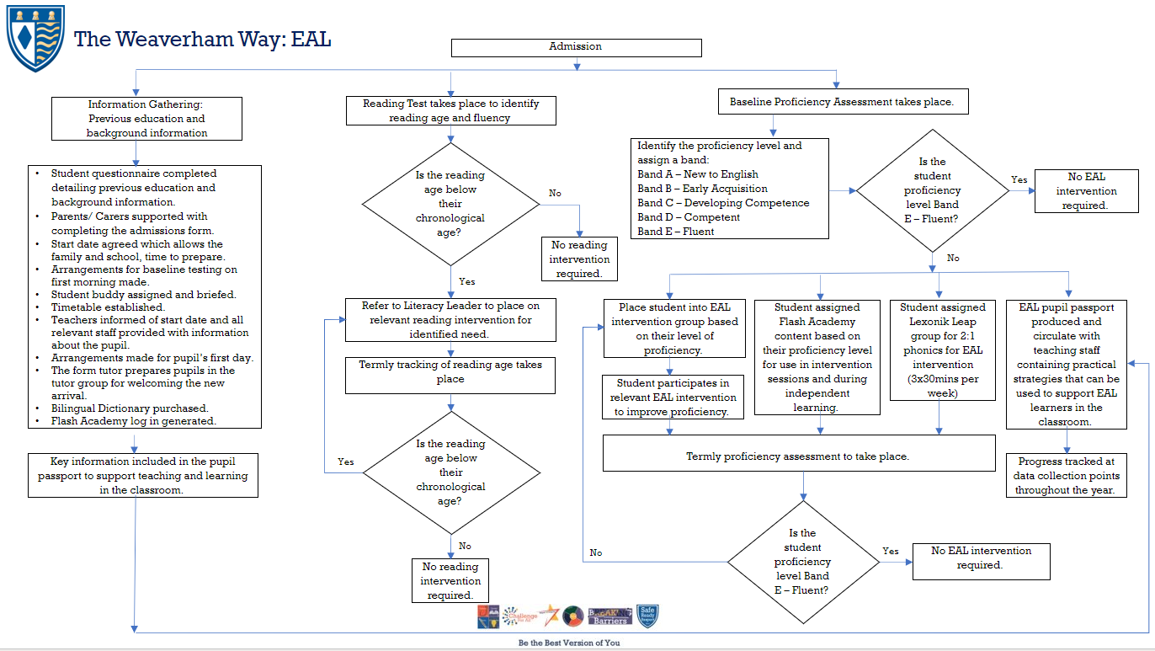

Platforms to support EAL Learners

- Flash Academy
- Lexonik Leap
- Say Hi
- Google Translate

Costing

Flash Academy App - £89 per licence (these are transferable if the student leaves and last for one calendar year.
Say Hi App – Free
Lexonik Leap – £500 per teaching box (The boxes have been purchased as part of the literacy intervention offer and therefore there is no additional cost for the EAL provision)
Bi Lingual Dictionaries - £9.99

Teaching and Learning

‘EAL pupils have a right to access the National Curriculum and the Early Years Foundation Stage. This is best achieved within a whole school context. Pupils learn more quickly when socialising and
interacting with their peers who speak English fluently and can provide good language and learning role models.’
Ofsted 2014

The home languages of all pupils and staff are recognised and valued at Weaverham High School. Pupils are encouraged to maintain their home language and, where appropriate, use it in the school environment. Although many students acquire the ability to communicate on a day-to-day basis in English quite quickly, the level of language needed for academic study is much deeper and more detailed, and can require continuing support for up to ten years.

Language develops best when used in purposeful contexts across the curriculum. The language demands of learning tasks need to be identified and included in planning. Teaching and support staff play a crucial role in modelling uses of language. Knowledge and skills developed in learning the first language aid the acquisition of additional language.

Using the pupils identified proficiency levels a pupil passport will be developed in order to inform relevant teaching and learning strategies that can be implemented in the classroom to aid the pupil’s access to the curriculum. This will be available to all staff in order to develop a consistent approach to teaching and each pupil and aid familiarisation for the pupil.

Special Educational Needs and Disabilities and Highly Able pupils

- Most EAL pupils needing additional support do not have SEND.
- Should SEND be identified, EAL pupils have equal access to school’s SEND provision.
- If EAL pupils are identified as Highly Able, they have equal access to the school’s Endeavour provision.

